# ­­BOOK STORE MANAGEMENT SYSTEM



Session: 2021 – 2024

**Submitted by:**

Muhammad Ibrahim       2021-CS-169

**Supervised by:**

Mis Maida Shahid

Department of Computer Science

**University of Engineering and Technology**

**Lahore Pakistan**

# CONTENTS

Project Description: 3

Users of Application: 3

Functional Requirements: 4

Wireframes of Application5

Data Structures: 11

Functions Prototypes: 11

Functions Working Flow: 13

Complete Code: 14

Test Cases for Project: 37

# PROJECT DESCRIPTION

My project is Book Store Management System. It is a business application which is console based. My basic purpose to make this application is to digitalize Pakistan. It helps book shop owner in multiple ways like

* creating customers’ accounts
* managing the expenditures of shop
* view customers (keeps the track of multiple customers)
* view shopping history
* keep the track of stock present in shop

On other side it also helps the customer in many ways like a customer can

* view all items present in shop,
* a customer can place his order if the required item is not present in shop
* he can also buy items using this application
* can change his pin

This application is very user friendly as it provides separate menu for admin as well as customers.

From security po of view a customer can only access the buying section if his account is created by the admin. In case of wrong user name or pin a customer cannot access to many useful features of customers’ menu.

# USERS OF APPLICATION

There are two types of users of this management system application which are as follows:

* Admin (owner of shop)
* Customer (total customers: 5)

# FUNCTIONAL REQUIREMENTS

**Admin:**

* I can add customers:
  + By name.
  + Give them their pin.
* View customers.
* Add stock to the exiting stock.
* View Bills of the customers.
* View the orders placed by the customers.
* Manage the expenditures of the shop.

**Customers:**

* I can view the items available.
* I can change my pin.
* Place the order If item is not available.
* Buy the required items:
* View the bill of shopping.

# WIRE FRAMES OF APPLICATION

MAIN MENU

*********************************************************

*Book Store Management System*

*********************************************************Welcome To Book Store

You want to login as an ADMIN OR CUSTOMER.

For ADMIN press 1

For CUSTOMER press 2

To EXIT program, press 3

Your option---

Press any key to continue-----

_

ADMIN MENU

**********************************************************

*Book Store Management System*

**********************************************************

Welcome To Book Store

Main Menu-----------------------------------------------

1-Add Customers

2-View Customers

3-View Bills (history)

4-View orders placed by the customers.

5-Add / Update stock of the shop.

6-Manage the expenditures of the shop.

7-Back to main menu.

Your option---

_

­­­­­­­­­­­­­­­­­­­

ADMIN OPTION-1

Enter name of customer:

_

Enter pin of customer:

_

ADMIN OPTION-2

Following(s) are customers and their pins:

Ali 1234

Ahmad 3231

Hassan 3433

Ibrahim 3434

Saad 2233

ADMIN OPTION-3

Followings are the bills of customers:

1-Ali Ahmed 2300

2-Asad 3400

3-Hassan 3500

4-Ibrahim 5000

ADMIN OPTION-4

Followings are the orders placed by the customers:

Ahmad Bahadur Pen, Eraser

Hassan English Book

3-Ibrahim Scale

ADMIN OPTION-5

Stock Management Menu--------------------------------------

1-Add Stock of shop

2-View added stock

3-Update added stock

4-Back to admin menu

Your option---

Following’s things have been added to the shop:

Pen 90

English Book 100

Scale 30

Books 200

Eraser 20

ADMIN OPTION-5(a)

Following’s things have been added to the shop:

Pen 90

English Book 100

Scale 30

Books 200

Eraser 20

Maximum number of stocks you can enter: 10

How many stocks you want to add?

_

Enter stock name:

_

Enter stock price:

_

Your stocks are being added.

ADMIN OPTION-5(b)

Following’s things have been added to the shop:

Pen 90

English Book 100

Scale 30

Books 200

Eraser 20

Following’s things have been added to the shop:

Pen 90

English Book 100

Scale 30

Books 200

Eraser 20

ADMIN OPTION-5(c)

Enter name of stock which you want to update:

_

Enter name of new stock:

_

Your stock is updated---

Following’s things have been added to the shop:

Pen 90

English Book 100

Scale 30

Books 200

Eraser 20

ADMIN OPTION-6

Shop Management Menu----------------------------------------

1-Add Bills of shop

2-View added bills

3-Update added bills

Your option---

ADMIN OPTION-6(a)

Enter bill name:

_

Enter bill amount:

_

Your bills added

ADMIN OPTION-6(b)

Your bills in ascending order are as show below:

Electricity Bill 12000

Food Bill 30000

Workers Salary 43000

Total expenditure 85000

ADMIN OPTION-6(c)

Enter name of bill which you want to update:

_

Enter amount of bill:

_

Your amount is updated---

CUSTOMER MENU

**********************************************************

*Book Store Management System*

**********************************************************

Welcome To Book Store

Main Menu--------------------------------------------------

1-View Items

2-Buy the required items

3-Change pin

4-Place orders

5-Back to main menu.

Your option---

CUSTOMER OPTION-1

Following(s) items are available in shop:

Pen 90

English Book 100

Scale 30

Books 200

Eraser 20

CUSTOMER OPTION-2

Enter name

_

Enter pin:

_

Enter number of items you want to buy:

_

Enter item name:

­­­­­­­_

Total Bill:

CUSTOMER OPTION-3

Enter name:

_

Enter pin:

_

Enter your new pin:

_

Your pin is being updated---

Your pin is updated successfully----

CUSTOMER OPTION-4

Enter name:

_

Enter pin:

_

Enter number of orders you want to place (max = 5):

_

Enter order:

_

# DATA STRUCTURES

**ARRAYS:**

In this application following arrays are used:

customer_n_a[N_CUSTOMER] = {" "} (names given by admin)

customer_p_a[N_CUSTOMER] = {" "} (pins given by admin)

customers_bills[N_CUSTOMER] = {0} (used to store the bills of customers)

stock_adding[N_STOCKS] = {" "} (used for adding stock of shop)

bills_shop[N_BILLS] = {0}     (used for adding bills of shop)

bills_shop_names[N_BILLS] = {" "} (used to store names of bills)

stock_prices[N_STOCKS] = {0} (used for adding prices of stock)

orders[N_ORDERS] = {" "}           (used for taking orders from customers)

customer_1[N_ORDERS] = {" "}       (store the orders placed by customer 1)

customer_2[N_ORDERS] = {" "}       (store the orders placed by customer 2)

customer_3[N_ORDERS] = {" "}       (store the orders placed by customer 3)

customer_4[N_ORDERS] = {" "}       (store the orders placed by customer 4)

customer_5[N_ORDERS] = {" "}       (store the orders placed by customer 5)

# FUNCTIONS PROTOTYPES

void header ()

int main_menu()

**FOR ADMIN SECTION:**

int admin_menu()

void add_customer()

void add_customer_array(string name, string pin)

void display_customer()

void display_customers_bills()

void display_order(string array[])

void view_orders()

int stock_management_menu()

void adding_stock_with_price()

void view_stock()

void update_stock()

int shop_management_menu()

void add_bills_shop()

void view_bills_shop()

void update_bill()

void sorting(int list[], string names[], int array_size)

**FOR CUSTOMER SECTION**

int customer_menu()

void view_items()

void clear_screen()

int calculateBill(string item)

void bill_generator()

void pin_change()

void order_placing()

**FOR FILE HANDLING**

loadcustomer()

savecustomerInFile(string name, string pin)

loadcustomer_bills()

save_customer_n_bill_infile(string name, int bill)

loadstockandprice()

savestockInFile()

# FUNCTIONS WORKING FLOW

# COMPLETE CODE

#include <iostream>

#include <stdlib.h>

#include <conio.h>

#include <fstream>

//----------------------PROBLEM IS IN BREAKOUTS RED DOTS CHECK IT--------------

using namespace std;

// CONST VARIABLES

int const N_CUSTOMER = 5;

int const N_STOCKS = 10;

int const N_BILLS = 4;

int const N_ORDERS = 10;

// GLOBAL VARIABLES

int count = 0;

int user_option;

int entry_count = 0;

int stock_count = 0;

int shop_bill_count = 0;

int customer_display = 0; // used for counting customer while displaying

int bill_count = 0;

int order_place_count = 0;

int pin_change_count = 0;

// GLOBAL ARRAYS

string customer_n_a[N_CUSTOMER] = {" "}; // names given by admin

string customer_p_a[N_CUSTOMER] = {" "}; // pins given by admin

int customers_bills[N_CUSTOMER] = {0}; // used to store the bills of customers.

string stock_adding[N_STOCKS] = {" "}; // used for adding stock of shop.

int bills_shop[N_BILLS] = {0}; // used for adding bills of shop.

string bills_shop_names[N_BILLS] = {" "}; // used to store names of bills.

int stock_prices[N_STOCKS] = {0}; // used for adding prices of stock.

string orders[N_ORDERS] = {" "}; // used for taking orders from customers

string customer_1[N_ORDERS] = {" "}; // used to store the orders placed by customer 1.

string customer_2[N_ORDERS] = {" "}; // used to store the orders placed by customer 2.

string customer_3[N_ORDERS] = {" "}; // used to store the orders placed by customer 3.

string customer_4[N_ORDERS] = {" "}; // used to store the orders placed by customer 4.

string customer_5[N_ORDERS] = {" "}; // used to store the orders placed by customer 5.

// PROTOTYPES 0F FUNCTIONS

void header();

int main_menu();

//------------------------FOR FILE HANDLING---------------------------

void loadcustomer(); // usedto load customers with pins from file

void savecustomerInFile(string name, string pin); // used to store data back to file

// used for customer billing section

void loadcustomer_bills();

void save_customer_n_bill_infile(string name, int bill);

// used for adding stock in file

void loadstockandprice();

void savestockInFile();

// used for adding shop bills in file

// void loadbills_shop();

// void saveshopbillsInFile(string name, int prices);

//------------------------FOR ADMIN SECTION---------------------------

int admin_menu();

void add_customer();

void add_customer_array(string name, string pin);

void display_customer();

void display_customers_bills();

void display_order(string array[]);

void view_orders();

int stock_management_menu();

void adding_stock_with_price();

void add_stock_in_array(string name, int price);

void view_stock();

void update_stock();

int shop_management_menu();

void add_bills_shop();

void add_shopbills_array(string name, int amount);

void view_bills_shop();

void update_bill();

void sorting(int list[], string names[], int array_size);

//------------------------FOR CUSTOMER SECTION---------------------------

int customer_menu();

void view_items();

void clear_screen();

int calculateBill(string item);

void bill_generator();

void store_bill(int bill, int count);

void pin_change();

void order_placing();

//------START OF MAIN-----------------

main()

{

// local VARIABLES

int main_option;

int admin_option;

int customer_option;

//---------load files-----------

loadcustomer();

loadcustomer_bills();

loadstockandprice();

// loadbills_shop();

//_______________END OF LOCAL VARIABLES___________________

while (true)

{

main_option = main_menu();

clear_screen();

if (main_option == 1) //------------start of ADMIN SECTION--------

{

while (true)

{

admin_option = admin_menu();

clear_screen();

//------------start of ADMIN OPTIONS--------

if (admin_option == 1) // for adding customers

{

add_customer();

clear_screen();

}

else if (admin_option == 2) // View Customers

{

if (customer_n_a[0] != " " && customer_p_a[0] != " ")

{

display_customer();

clear_screen();

}

else

{

cout << "No customer is being added yet" << endl;

cout << endl;

clear_screen();

}

}

else if (admin_option == 3) // View Bills (history)

{

if (customer_n_a[0] != " " && customers_bills[0] != 0)

{

display_customers_bills();

clear_screen();

}

else

{

cout << "No customer has done shoping yet" << endl;

cout << endl;

clear_screen();

}

}

else if (admin_option == 4) // View odders placed by the customers

{

if (customer_1[1] != " ")

{

view_orders();

clear_screen();

}

else

{

cout << "No order has been placed." << endl;

cout << endl;

clear_screen();

}

}

else if (admin_option == 5) // Add / Update stock of the shop

{

int Stock_menu_option;

while (true)

{

Stock_menu_option = stock_management_menu();

clear_screen();

if (Stock_menu_option == 1)

{

adding_stock_with_price();

clear_screen();

}

else if (Stock_menu_option == 2)

{

if (stock_prices[0] != 0 && stock_adding[0] != " ")

{

view_stock();

clear_screen();

}

else

{

cout << "No stock has been added yet." << endl;

clear_screen();

}

}

else if (Stock_menu_option == 3)

{

update_stock();

clear_screen();

}

else if (Stock_menu_option == 4)

{

savestockInFile();

break;

}

else

{

cout << "Enter a valid input" << endl;

clear_screen();

break;

}

}

}

else if (admin_option == 6) // Manage the expenditures of the shop

{

int Shop_menu_option;

while (true)

{

Shop_menu_option = shop_management_menu();

clear_screen();

if (Shop_menu_option == 1)

{

add_bills_shop();

clear_screen();

}

else if (Shop_menu_option == 2)

{

if (bills_shop_names[0] != " ")

{

view_bills_shop();

clear_screen();

}

else

{

cout << "No bills are added by the admin." << endl;

cout << endl;

clear_screen();

}

}

else if (Shop_menu_option == 3)

{

update_bill();

clear_screen();

}

else if (Shop_menu_option == 4)

{

break;

}

else

{

cout << "Enter a valid input" << endl;

cout << endl;

clear_screen();

break;

}

}

}

else if (admin_option == 7) // exit from admin section

{

break;

}

else

{

cout << "Invalid input" << endl;

cout << endl;

clear_screen();

break;

}

} // END OF WHILE LOOP

} // END OF ADMIN SECTION

else if (main_option == 2) //------------start of CUSTOMER SECTION--------

{

while (true)

{

customer_option = customer_menu();

clear_screen();

//------------start of CUSTOMER OPTIONS--------

if (customer_option == 1) // View Items

{

if (stock_adding[0] != " ")

{

view_items();

clear_screen();

}

else

{

cout << "There is no stock to display" << endl;

cout << endl;

clear_screen();

}

}

else if (customer_option == 2) // Buy the required items

{

bill_generator();

clear_screen();

}

else if (customer_option == 3) // Change pin

{

pin_change();

clear_screen();

}

else if (customer_option == 4) // Place odders

{

order_placing();

clear_screen();

}

else if (customer_option == 5) // exit from customer section

{

break;

}

else

{

cout << "Invalid input" << endl;

cout << endl;

clear_screen();

break;

}

} // END OF WHILE LOOP

} // END OF CUSTOMER SECTION

else if (main_option == 3) //-------- EXIT FROM THE PROGRAM------

{

cout << "Thanks for using BOOK STORE MANAGEMENT SYSTEM." << endl;

cout << endl;

break;

}

else //--------------IN CASE OF WRONG INPUT OF MAIN MENU--------

{

cout << "Enter a valid input" << endl;

clear_screen();

continue;

}

} //----------END OF WHILE LOOP------------------

} // END OF MAIN

//--------------FUNCTIONS-------------------

void header()

{

cout << "***************************************************************** " << endl;

cout << " *Book Store Management System* " << endl;

cout << "***************************************************************** " << endl;

}

int main_menu()

{

header();

cout << " " << endl;

cout << " Welcome To Book Store " << endl;

cout << " " << endl;

cout << "You want to login as an ADMIN OR CUSTOMER. " << endl;

cout << " " << endl;

cout << "For ADMIN press 1. " << endl;

cout << "For CUSTOMER press 2. " << endl;

cout << "To EXIT program, press 3. " << endl;

cout << " " << endl;

// OPTION FROM USER.

cout << "Your option--- " << endl;

cin >> user_option;

return user_option;

}

//------------------------FOR ADMIN SECTION---------------------------

int admin_menu()

{

header();

cout << " " << endl;

cout << " Welcome To Book Store " << endl;

cout << " " << endl;

cout << "Main Menu--------------------------------------------------------" << endl;

cout << " " << endl;

cout << "1-Add Customers" << endl;

cout << "2-View Customers" << endl;

cout << "3-View Bills (history)" << endl;

cout << "4-View odders placed by the customers." << endl;

cout << "5-Add / Update stock of the shop." << endl;

cout << "6-Manage the expenditures of the shop." << endl;

cout << "7-Back to main menu." << endl;

cout << "Your option--- " << endl;

cin >> user_option;

return user_option;

}

void loadcustomer()

{

fstream file;

file.open("names_pins.txt", ios::in);

string name, pin;

entry_count = 0;

while (!file.eof())

{

file >> name;

file >> pin;

add_customer_array(name, pin);

}

file.close();

}

void savecustomerInFile(string name, string pin)

{

fstream file;

file.open("names_pins.txt", ios::out);

file << "\n"

<< name << " " << pin;

// cout << "Record saved into file " << endl;

file.close();

}

void add_customer()

{

if (entry_count < 5)

{

string name, pin;

cout << "Enter customer name" << endl;

cin >> name;

cout << "Enter customer pin" << endl;

cin >> pin;

add_customer_array(name, pin);

savecustomerInFile(name, pin);

}

else

{

cout << "Only " << N_CUSTOMER << " can be added " << endl;

}

}

void add_customer_array(string name, string pin)

{

customer_n_a[entry_count] = name;

customer_p_a[entry_count] = pin;

entry_count++;

}

void display_customer()

{

if (entry_count < N_CUSTOMER)

{

cout << "Name\tPin" << endl;

for (int i = 0; i < entry_count; i++)

{

cout << customer_n_a[i] << "\t" << customer_p_a[i] << endl;

}

}

else

{

cout << "Name\tPin" << endl;

for (int i = 0; i < N_CUSTOMER; i++)

{

cout << customer_n_a[i] << "\t" << customer_p_a[i] << endl;

}

}

}

void display_customers_bills()

{

cout << "Following(s) are the customers and their bills : " << endl;

cout << "Name\t\t\tBill" << endl;

if (bill_count < N_CUSTOMER)

{

for (int i = 0; i <= bill_count; i++)

{

if (customer_n_a[i] != " " && customers_bills[i] != 0)

cout << customer_n_a[i] << "\t\t\t" << customers_bills[i] << endl;

}

}

else

{

for (int i = 0; i <= N_CUSTOMER - 1; i++)

{

cout << customer_n_a[i] << "\t\t\t" << customers_bills[i] << endl;

}

}

}

void display_order(string array[]) // used in another function for displaying array.

{

int index = 0;

while (array[index] != "\0")

{

cout << array[index] << " ";

index++;

}

}

void view_orders()

{

if (orders[0] != " ")

{

cout << "Following are the orders." << endl;

cout << endl;

if (customer_1[0] != " " && customer_1[0] != " ")

{

cout << customer_n_a[0] << "\t";

display_order(customer_1);

cout << endl;

}

if (customer_2[0] != " ")

{

cout << customer_n_a[1] << "\t";

display_order(customer_2);

cout << endl;

}

if (customer_3[0] != " ")

{

cout << customer_n_a[2] << "\t";

display_order(customer_3);

cout << endl;

}

if (customer_4[0] != " ")

{

cout << customer_n_a[3] << "\t";

display_order(customer_4);

cout << endl;

}

if (customer_5[0] != " ")

{

cout << customer_n_a[4] << "\t";

display_order(customer_5);

cout << endl;

}

}

else

{

cout << "No order have been placed yet." << endl;

}

}

int stock_management_menu()

{

header();

cout << " " << endl;

cout << "Stock Management Menu--------------------------------------------------------" << endl;

cout << " " << endl;

cout << "1-Add Stock of shop" << endl;

cout << "2-View added stock " << endl;

cout << "3-Update added stock" << endl;

cout << "4-Back to admin menu" << endl;

cout << "Your option--- " << endl;

cin >> user_option;

return user_option;

}

void loadstockandprice()

{

fstream file;

file.open("stocks_of_shop.txt", ios::in);

string name;

int price;

// stock_count = 0;

while (!file.eof())

{

file >> name;

file >> price;

add_stock_in_array(name, price);

}

file.close();

}

void add_stock_in_array(string name, int price)

{

stock_adding[stock_count] = name;

stock_prices[stock_count] = price;

stock_count++;

}

void savestockInFile()

{

fstream file;

int index = 0;

file.open("names_pins.txt", ios::out);

while (index < stock_count)

{

file << "\n"

<< stock_adding[index] << " " << stock_prices[index];

index++;

}

// cout << "Record saved into file " << endl;

file.close();

}

void adding_stock_with_price()

{

if (stock_count < 10)

{

int n_stock;

cout << "Maximum number of stocks you can enter : " << N_STOCKS << endl;

cout << "How many stocks you want to add : ";

cin >> n_stock;

string name;

int prices;

for (int i = 0; i < n_stock; i++)

{

cout << "Enter stock " << i + 1 << " : ";

cin >> name;

cout << "Enter stock " << i + 1 << " price : ";

cin >> prices;

add_stock_in_array(name, prices);

}

cout << "You stocks are being added." << endl;

}

else

{

cout << "You can only add " << N_STOCKS << " stocks" << endl;

}

}

void view_stock()

{

cout << "Following are the stocks added by ADMIN." << endl;

cout << "Item\t\tPrice(Rs)" << endl;

for (int i = 0; i < stock_count; i++)

{

cout << stock_adding[i] << "\t\t" << stock_prices[i] << endl;

}

}

void update_stock()

{

string stock_name, stock_name_final;

cout << "Enter name of stock which you want to update : ";

cin >> stock_name;

cout << "Enter name of new stock : ";

cin >> stock_name_final;

int index = 0;

while (stock_adding[index] != "\0")

{

if (stock_adding[index] == stock_name)

{

stock_adding[index] = stock_name_final;

}

index++;

}

cout << "Your stock is updated---" << endl;

}

int shop_management_menu()

{

header();

cout << " " << endl;

cout << "Shop Management Menu--------------------------------------------" << endl;

cout << " " << endl;

cout << "1-Add Bills of shop" << endl;

cout << "2-View added bills " << endl;

cout << "3-Update added bills" << endl;

cout << "4-Back to admin menu" << endl;

cout << "Your option--- " << endl;

cin >> user_option;

return user_option;

}

void loadbills_shop()

{

fstream file;

file.open("bills_of_shop.txt", ios::in);

string name;

int amount;

shop_bill_count = 0;

while (!file.eof())

{

file >> name;

file >> amount;

add_stock_in_array(name, amount);

}

file.close();

}

void add_shopbills_array(string name, int amount)

{

bills_shop_names[shop_bill_count] = name;

bills_shop[shop_bill_count] = amount;

shop_bill_count++;

}

void saveshopbillsInFile(string name, int prices)

{

fstream file;

file.open("bills_of_shop.txt", ios::app);

file << "\n"

<< name << " " << prices << endl;

// cout << "Record saved into file " << endl;

file.close();

}

void add_bills_shop()

{

if (shop_bill_count < N_BILLS)

{

string bill_name;

int bill_amount;

for (int i = 0; i < N_BILLS; i++)

{

cout << "Enter bill " << i + 1 << " name : ";

cin >> bill_name;

cout << "Enter " << bill_name << " bill amount : ";

cin >> bill_amount;

add_shopbills_array(bill_name, bill_amount);

saveshopbillsInFile(bill_name, bill_amount);

}

cout << "Your bills added" << endl;

}

else

{

cout << "You can only add " << N_BILLS << " types of bills" << endl;

}

}

void sorting(int list[], string names[], int array_size)

{

int min;

int i;

int j;

int loc;

int temp;

string temp_name;

for (i = 0; i < array_size - 1; i++)

{

min = list[i];

loc = i; // INDEX OF LIST[i].

for (j = i + 1; j < array_size; j++)

{

if (list[j] < min)

{

min = list[j];

loc = j;

}

temp = list[i]; // IT STORES THE VALUE OF FIRST ELEMENT OF ARRAY IN SEPERATE VARIABLE.

temp_name = names[i]; // FOR NAME SWAPING

list[i] = list[loc]; // IT PLACE THE SMALLEST VALUE TO FIRST PLACE.

names[i] = names[loc]; // FOR NAME SWAPING

list[loc] = temp; // IT PLACE THE ELEMENT PLACED IN SEPERATE VARIABLE TO THE LOCATION WHERE SMALLEST VALUE WAS FOUND.

names[loc] = temp_name; // FOR NAME SWAPING

}

}

}

void view_bills_shop()

{

cout << "Your bills in asseding order are as show below : " << endl;

cout << "Name\t\tAmount(Rs)" << endl;

sorting(bills_shop, bills_shop_names, N_BILLS);

int total;

for (int i = 0; i < N_BILLS; i++)

{

cout << bills_shop_names[i] << ":\t\t" << bills_shop[i] << endl;

total = total + bills_shop[i];

}

cout << "Total expenditure"

<< ":\t\t" << total - 4 << endl;

}

void update_bill()

{

string bill_name;

int bill_amount_final;

cout << "Enter name of bill which you want to update : ";

cin >> bill_name;

cout << "Enter amount of bill : ";

cin >> bill_amount_final;

for (int index = 0; index < N_BILLS; index++)

{

if (bills_shop_names[index] == bill_name)

{

bills_shop[index] = bill_amount_final;

}

}

cout << "Your amount is updated---" << endl;

}

//------------------------FOR CUSTOMER SECTION---------------------------

int customer_menu()

{

header();

cout << " " << endl;

cout << " Welcome To Book Store " << endl;

cout << " " << endl;

cout << "Main Menu--------------------------------------------------------" << endl;

cout << " " << endl;

cout << "1-View Items" << endl;

cout << "2-Buy the required items" << endl;

cout << "3-Change pin" << endl;

cout << "4-Place odders." << endl;

cout << "5-Back to main menu." << endl;

cout << "Your option--- " << endl;

cin >> user_option;

return user_option;

}

void view_items()

{

cout << "Following(s) items are available in shop:" << endl;

cout << endl;

int index = 0;

cout << "Item\t\tPrice(Rs)" << endl;

while (stock_adding[index] != "\0")

{

cout << stock_adding[index] << "\t\t" << stock_prices[index] << endl;

index++;

}

}

int calculateBill(string item)

{

int price;

int index = 0;

while (stock_adding[index] != "\0")

{

if (item == stock_adding[index])

{

price = stock_prices[index];

}

index++;

}

return price;

}

void bill_generator()

{

string customer_n, customer_p;

cout << "Enter name : ";

cin >> customer_n;

cout << "Enter pin : ";

cin >> customer_p;

if (customer_n_a[bill_count] == customer_n && customer_p_a[bill_count] == customer_p)

{

int n;

int bill;

int t_bill = 0;

string item;

cout << "Enter number of items you want to buy : " << endl;

cin >> n;

for (int i = 0; i < n; i++)

{

cout << "Enter item name:";

cin >> item;

bill = calculateBill(item);

t_bill = t_bill + bill;

}

cout << "Total Bill :\t" << t_bill << endl;

store_bill(t_bill, bill_count);

save_customer_n_bill_infile(customer_n, t_bill);

bill_count++;

}

else

{

cout << "User_name or pin is wrong." << endl;

}

}

void store_bill(int bill, int count)

{

customers_bills[count] = bill;

}

void loadcustomer_bills()

{

fstream file;

file.open("names_bills.txt", ios::in);

string name;

int bill;

bill_count = 0;

while (!file.eof())

{

file >> name;

file >> bill;

store_bill(bill, bill_count);

}

file.close();

}

void save_customer_n_bill_infile(string name, int bill)

{

fstream file;

file.open("names_bills.txt", ios::app);

file << "\n"

<< name << " " << bill << endl;

cout << "Record saved into file " << endl;

file.close();

}

void pin_change()

{

string customer_n, customer_p;

cout << "Enter name : ";

cin >> customer_n;

cout << "Enter pin : ";

cin >> customer_p;

if (customer_n_a[pin_change_count] == customer_n && customer_p_a[pin_change_count] == customer_p)

{

string customer_p_changed;

cout << "Enter your new pin : ";

cin >> customer_p_changed;

customer_p_a[pin_change_count] = customer_p_changed;

cout << "Your pin is being updated---" << endl;

cout << "Your pin is updated successfully----" << endl;

pin_change_count++;

}

else

{

cout << "User_name or pin is wrong " << endl;

}

}

void order_placing()

{

string customer_n, customer_p;

cout << "Enter name : ";

cin >> customer_n;

cout << "Enter pin : ";

cin >> customer_p;

if (customer_n_a[order_place_count] == customer_n && customer_p_a[order_place_count] == customer_p)

{

int n;

cout << "Enter number of orders you want to place (max = 5) : ";

cin >> n;

for (int i = 0; i < n; i++)

{

cout << "Enter order " << i + 1 << " : ";

cin >> orders[i];

}

// cout << "Nmae " << customer_n << endl;

// cout << "Name in array " << customer_n_a[0] << endl;

// cout << "Checking array:" << endl;

// for (int i = 0; i < n; i++)

// {

// cout << orders[i] << " ";

// }

// cout << endl;

if (customer_n == customer_n_a[0])

{

for (int i = 0; i < n; i++)

{

customer_1[i] = orders[i];

}

}

else if (customer_n == customer_n_a[1])

{

for (int i = 0; i < n; i++)

{

customer_2[i] = orders[i];

}

}

else if (customer_n == customer_3[0])

{

for (int i = 0; i < n; i++)

{

customer_3[i] = orders[i];

}

}

else if (customer_n == customer_4[0])

{

for (int i = 0; i < n; i++)

{

customer_4[i] = orders[i];

}

}

else if (customer_n == customer_5[0])

{

for (int i = 0; i < n; i++)

{

customer_5[i] = orders[i];

}

}

order_place_count++;

}

else

{

cout << "User_name or pin is wrong " << endl;

}

}

//------------------------FOR CLEARING SCREEN---------------------------

void clear_screen()

{

cout << "Press any key to continue.";

getch();

system("cls");

}

# TEST CASES FOR PROJECT

**MAIN MENU**

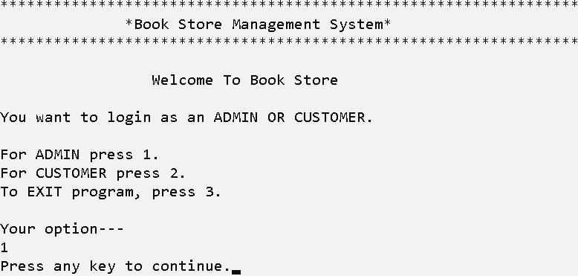

**ADMIN MENU**

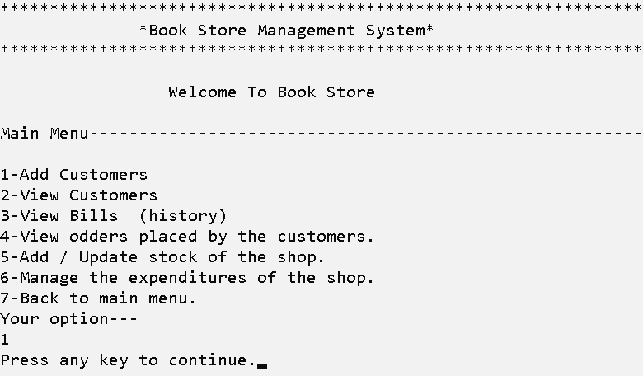

**ADMIN SECTION**

**OPTION 1**

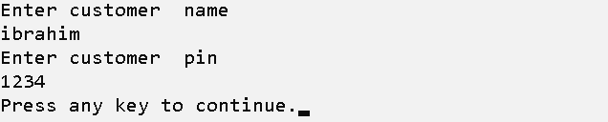

**OPTION 2**

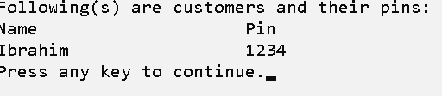

**OPTION 3**

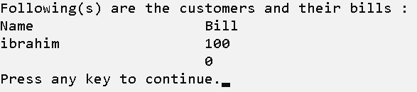

**OPTION 4**

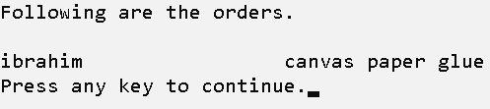

**OPTION 5**(**STOCK MANAEMENT MENU)**

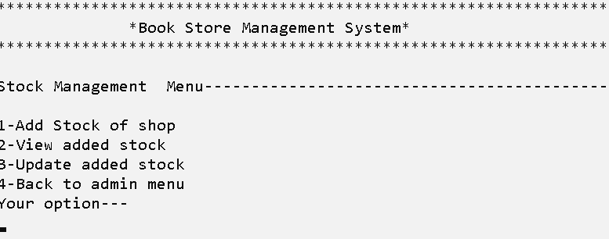

**Option 1**

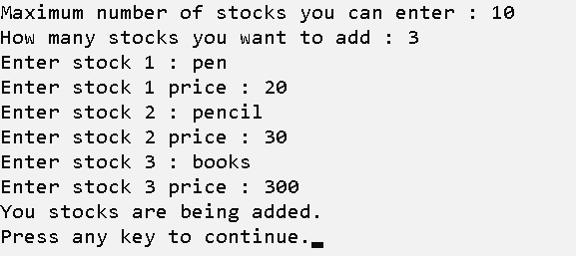

**Option 2**

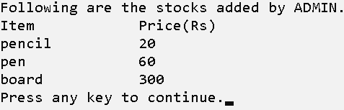

**Option 3**

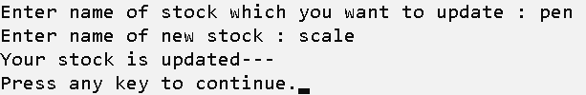

**OPTION 6**(**SHOP MANAGEMENT MENU**)

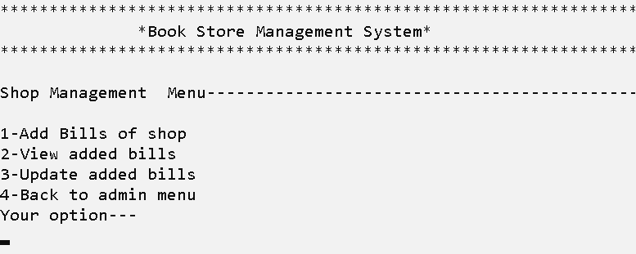

**Option 1**

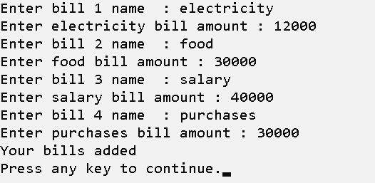

**Option 2**

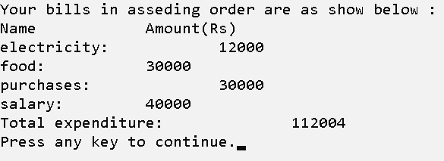

**Option 3**

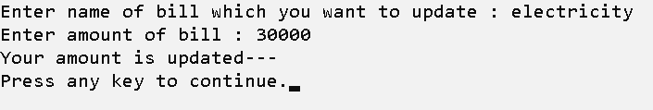

**CUSTOMER MENU**

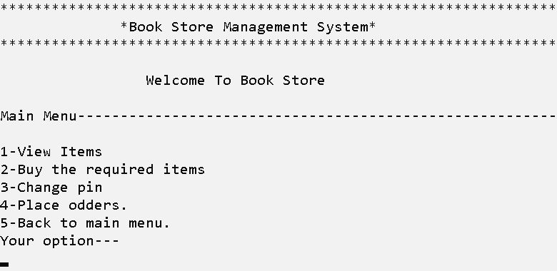

**CUSTOMER SECTION**

**OPTION 1**

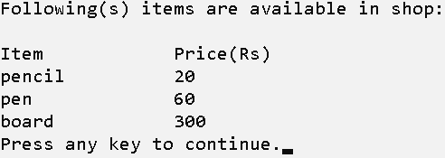

**OPTION 2**

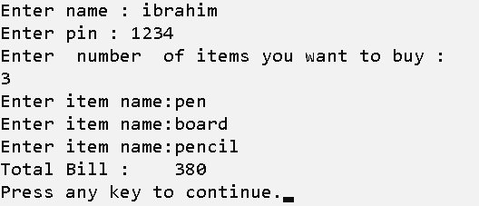

**OPTION 3**

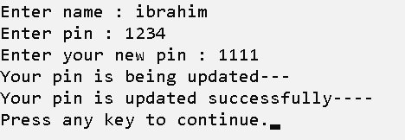

**OPTION 4**

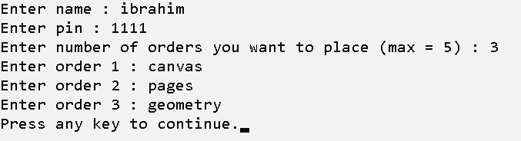

**END SECTION**

